# 

# **Predicting Kickstarter Campaigns**

**Fardin Hafiz, Leshauna Hartman**, **Rachel Thomas**, **Tanya Visser**

# **The George Washington University**

# **Introduction to Data Mining**

# **Professor Divya Pandove Narula**

# **Tuesday 17th December 2024**

## **Introduction**

Kickstarter is a crowd-sourcing platform that allows creators of all sorts to share their prospective work to attract community funding. Launched in 2009, Kickstarter has since become a Public Benefit Corporation that has funded more than 270,000 projects and raised more than $8 billion dollars. Kickstarter creators post their ideas or projects on the website and share them with friends and supporters, who, in turn, share the project in their networks, and so on. More than 24 million people from all over the world have helped fund Kickstarter campaigns. Projects cover a wide range of categories including art, publishing, design, and technology. “Kickstarter lifts the creative class, gives people the tools to pursue daring ideas on their own terms, and helps creators build communities around their work” ([www.kickstarter.com](http://www.kickstarter.com)).

We are interested in predicting the success or failure of Kickstarter projects and identifying the characteristics of a project that most influence this outcome. This has practical implications as creators can tweak their projects to reflect a higher chance of success. Additionally, backers can make better decisions about which projects to fund. This saves time, money, and resources for both the creators and the backers.

Kickstarter is an “all or none” funding scheme, meaning if a campaign does not raise the entirety of its goal funding, it gets zero funding, all the money pledged everts to the donors, and the project fails.

## **Research Questions**

Our research questions were designed using the **SMART** framework – Specific, Measurable, Achievable, Relevant, and Time-bound. This analysis seeks to answer the following:

1. Which variables most influence success or failure?
2. Can a logistic regression model accurately predict the success or failure of a Kickstarter campaign?
3. Can a Decision Tree accurately predict the success or failure of a Kickstarter campaign?
4. What are the top five (5) categories with the highest percentage of successes?
5. What percentage of all campaigns were successful compared to failed?

Through these questions, we aim to determine if Kickstarter campaign outcomes are predictable and identify which features/attributes contribute to the success of a campaign.

## **Dataset Description & Preparation**

**Dataset Overview**

The dataset was sourced from Kaggle and contains 378,661 observations with 15 variables. These variables include:

* **backers:** The total number of backers who supported a project.
* **currency:** The currency in which the project was originally launched.
* **country:** The country from which the project was launched.
* **main_category:** The primary category of the project (e.g., Music, Technology).
* **state:** The final status of the project, indicating whether it was successful, failed, or canceled.
* **usd_pledged_real:** The total amount of money pledged to a project in USD.
* **usd_goal_real:** The funding goal set by the project creators in USD.

**Data Preprocessing/Cleaning**

After sourcing the dataset, it was subsetted to include only campaigns that were successful or failed – rows reflecting any other campaign states were removed. This reduced the dataset to approximately 331,000 observations. A new variable called Duration, was created by finding the difference between the “launched” and “deadline” variables. “main_category”, “currency”, “state” and “country” variable were converted to categorical data types. A subset called kickstarter_final was created to include “main_category”, “currency”, “state”, “backers”, “country”, “usd_pledged_real”, “usd_goal_real”, and “Duration”.

**Literature Review**

Online crowdfunding platforms are an increasingly popular way for ordinary people to finance a wide variety of projects ranging from creative arts to healthcare support. Though there have been many platforms, Kickstarter is regarded as the largest and most impactful. In a 2016 study, Ethan Mollick of the Wharton School at the University of Pennsylvania, reported that each dollar given to projects via Kickstarter resulted in a mean of $2.46 in additional revenue (though this was not spread evening though categories). He also reported that Kickstarter projects had resulted in more than 5,000 ongoing full time jobs besides those of the creators, and more than 160,000 temporary positions. The successful campaign also resulted in more than 2,600 patent applications (Mollick, 2016). However, as more campaign have been launched, there has been an observed decrease in success rate, suspected to be due to campaign launches without sufficient preparation or experience. Tran, et al, showed that campaigns with significantly lower goals and significantly increased advertisement (via Twitter posts), were more successful (Tran et al., 2016).

**Exploratory Data Analysis**

We started the analysis with some exploratory graphing, to understand the variables better.

Figure 1. Distribution of final campaign state

You can see above (Fig. 1) that failed projects exceed successful projects across this dataset. This is not surprising, given the previous body of knowledge about crowdfunding in general, and Kickstarter specifically.

Next we examined the distribution of project outcomes by currency and country. You can clearly see in the graphs below that projects based in the US and funded with the US Dollar far outnumber those in any other currency (Fig. 2) or country (Fig. 3).

Figure 2. Distribution of final campaign state by country

Figure 3. Distribution of final campaign outcome by currency

Identifying the top five categories with the most successful projects, the table above highlights the areas where Kickstarter campaigns tend to achieve the most success. These categories are Dance, Theater, Comics, Music, and Art.

|  |  |
| --- | --- |
| **Top 5 Categories with the Highest Percentage of Successful Projects:** | |
| **Main Category** | **Percentage** |
| Dance | 65.44% |
| Theater | 63.8% |
| Comics | 59.14% |
| Music | 52.66% |
| Art | 44.89% |

To make these insights more visually appealing and intuitive, these values can be represented in a bar chart as seen below (Fig. 4):

Figure 4. Top 5 categories with highest percentage of successful projects

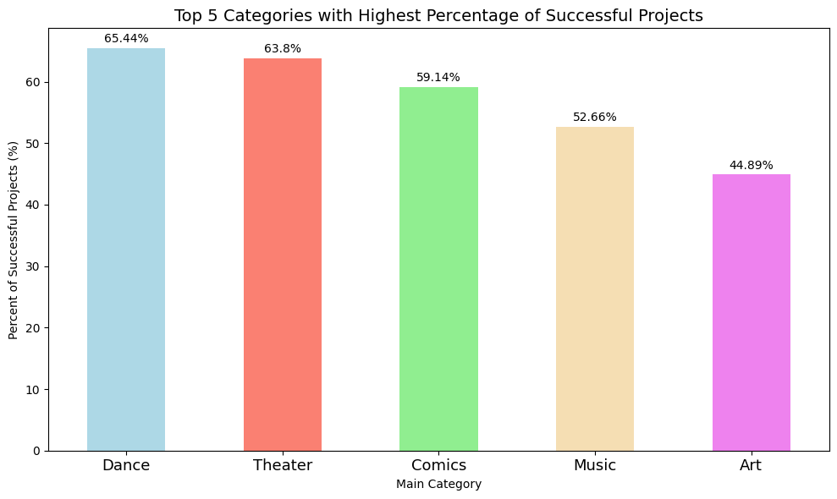

Successful campaigns have more backers and smaller funding goals, while failed campaigns have fewer backer and large to extremely large finding goals (Fig. 5). This is intuitively logical as large goals may dissuade backers due to a perception of unattainability leading to failure.

## **Modeling Techniques & Evaluation**

Figure 5. Final campaign state by number of backers and funding goal

This is a binary classification problem, predicting the likelihood of a successful Kickstarter campaign. We used both a decision tree (a machine learning model), and a logistic regression model.

**Classification Decision tree**

To create the decision tree, we created a training set and then fit a tree to max depth 8. This produced a complex tree with 34 leaf nodes, but training error rate of 0. The test error rate for this tree was 5.2% which is good, however the size of the tree makes it very complex to understand and we strongly suspected this tree was overfitting the data.

Figure 6. Decision tree, max depth 8

We then tried trees at depths 3. 4. and 5. To compare the models at the different depths, we completed cross validation at each and compared the scores using T-tests.

Figure 7. Comparison of cross validation depths to find ideal maximum depth

The model with max depth 4 performed statistically better than the model with max depth 3, but the model with max depth 5 was not statistically better than the model with max depth 4. We also performed a validation curve for the tree which showed the ideal depth is probably around 5-6 based on the point at which both the training score and the validation score are at their highest.

Figure 8. Validation curve for Kickstarter decision tree

However the models at these depths are very complex and much more difficult to understand. So we elected to use the model with max depth 4 as we felt the slight increase error rate was acceptable in exchange for a much simpler model with only 15 terminal leaf nodes.

Figure 9. Final decision tree, max depth 4

To interpret the tree, we generated a text summary which is significantly more readable than the tree plot.

This tree splits first by backers, then by goal, then by pledged amount, and then category, with a small influence of country of backers.

Path 1 has <= 12.5 backers, a goal <= $650, pledge amount <= $184.81, and not in Music are likely to fail.

Path 2 has <= 12.5 backers, a goal <= $650, pledge amount > #184.81, and not in Publishing are likely to succeed.

Path 3 has <= 12.5 backers, a goal > $650, having a specific country, and in Dance will likely fail.

Path 4 has >12.5 backers but <= 67.5, a goal <= $4747, and any value pledged is likely to be successful.

Path 5 has > 12.5 backers but <= 67.5, a goal is > $4747, and pledged <= $6322.9 are likely to fail, but > $6322.9 are likely to succeed.

Path 6 has > 67.5 backers, a goal <= $36970.10, and not Crafts are likely to succeed and if Crafts is likely to fail.

Path 7 has >67.5 backers, a goal > $36970, and pledged amount <= $38512.01 are like to fail, but if > $38512.01 are likely to be successful.

Overall, backers are the most significant predictor. Projects with fewer than 12.5 backers are most likely to fail regardless of other factors. Projects with backers between 12.5-67.5 backers increased the likelihood of success as long as goals re small to moderate. Projects with > 67.5 backers have the highest likelihood of success, even with higher funding goals. Small funding goals succeed more often, with projects with a goal less than $4747 (and especially less than $650), are highly likely to succeed assuming they get some backers and some pledged amount. Low pledged amounts leads to failure, especially for high goals. Categories play an overall secondary role, though funding for Craft projects is likely to fail in most scenarios. There may be some small regional effects, but they are not substantial.

We then fit the test data to the model and created a confusion matrix to assess the error.

Figure 10. Confusion matrix for decision tree, max depth 4

The tree at depth 3 was reasonably easy to understand and had a training error rate of only 6.9%, and a test error rate of 10.6%. At max depth 4, the training error rate was 6.87% and the test error rate was 8.4%. At max depth 5, the training error was only 1.6% and the test error 6.4%. We decided max depth 4 provided the best balance between accuracy and readability or utility, without risk of overfitting.

**Logistic Regression**

To further determine if we can accurately predict the success or failure of a Kickstarter campaign, a logistic regression model was built.

This model uses three predictors, **backers**, **usd_pledged_real**, and **main_category,** for its prediction. The dataset was split into a training set (70%) and a testing set (30%) using the ***train_test_split()*** function. The model’s summary can be observed and further insights stated below:

* **Test set accuracy:** 82.41%
* **Train set accuracy:** 82.16%

The similarity in accuracy for both test and train sets indicates that the model generalizes well to unseen data.

Figure 7. Logistic Regression Model Summary

From this model it is observed that:

* **Backers (Coefficient = 0.024616; Odds Ratio = 1.0249):**
  + Each unit increase in backers (i.e. each additional backer), the **odds of success** increases by a factor of approximately 1.03. Therefore, for each additional backer a project has, its likelihood of success increases.
* **USD Pledged (Coefficient = 0.000042; Odds Ratio = 1.00004):**
  + Although the effect of this feature is small, a 1 unit increase in pledged funds has a positive effect on success likelihood, as it increases the odds of success by a factor of 1.
* **Main Categories:**
  + This model uses the “Art” category as the baseline for comparison. From the summary:
    - Categories such as **Comics, Dance, Music, Film and Video and Theater,** have positive coefficients and odds ratios greater than 0, meaning that campaigns in these categories are more likely to succeed compared to campaigns in the **Art** category. For example, campaigns in the **Theater** category increases the odds of success by a factor of 2.89 when compared to those in the **Art** category.
    - Categories like **Crafts, Fashion, Technology, Games, and Food** have negative coefficients, indicating that campaigns in these categories have a lower odds of success when compared to the baseline category, **Art**. For example, projects considered within the **Games** category are less likely to be successful than those in the **Art** category as it odds ratio is approximately 0.3397.

The confusion matrix and classification report can be seen below.

From this matrix, the False Positive Rate (FPR) and False Negative Rate (FNR) can be derived and evaluated.

Figure 8. Confusion Matrix and ROC Curve of Logit Model

Regression Model

Summary

The Area Under the Curve is observed to be 90%, which states that the model is doing a good job at distinguishing between classes.

Figure 9. Classification Report of Logistic Regression Model

Summary

**F1-score:**

* The model’s F1-Score of 0.82 (82%)represents the balance between precision and recall, indicating that the model is performing well overall. However, there is room for improvement in minimizing false negatives.

**False Positive Rate (FPR): 5.89%**

* This FPR value indicates that among projects 5.89% of failed projects were incorrectly classified as successful by the model.

**False Negative Rate (FNR): 34.99%**

* The FNR of 34.99% implies that 34.99% of successful projects were incorrectly classified as not successful (*failed*) by the model.

This high FNR indicates the model has difficulty identifying successful projects. To address this high FNR value, the cutoff was lowered to 0.3.

**Adjusting Threshold**

After refitting this model with the new threshold, the following metrics were obtained:

Figure 10. Classification Report at Threshold 0.3

Summary

**Accuracy**: **83%**

* The model correctly predicted the outcome (success or failure) 83% of the time across all the projects.

**Precision: 84%**

* Although the average precision is approximately 84%, there is a large difference between the precision of the two classes. The model has a higher precision at predicting failures than successes.

**F-1 Score: 84%**

* While slightly lower for successes than for failures, the model still does generally well with balancing precision and recall, with a slight increase at the new threshold of 0.3 compared to 0.5. This indicates the model is good for capturing successful projects.

With further evaluation, the confusion matrix can then be rebuilt, this time at a threshold of 0.3. This figure can be observed below:

Figure 11. Confusion Matrix at Threshold 0.3

Summary

The new FPR and FNR is calculated from this matrix. Compared to the original model with the default threshold of 0.5, reducing the threshold value has decreased the FNR and increased the FPR.

**False Positive Rate (FPR):**

The FPR is calculated to be **18.64%,** indicating that 18.64% of the failed projects were incorrectly classified as successful.

**False Negative Rate (FNR):**

The FNR value of **13.55%** shows that 13.55% of the actual positive samples (i.e. successful projects) were incorrectly classified as failed. Although the FPR has increased, there is more of a balance between the two rates.

When comparing the models at different cutoffs, overall, lowering the threshold from 0.5 to 0.3 resulted in a slight improvement in accuracy from (82.41% to 83%). The F-1 score increased slightly at a cutoff of 0.3, indicating a better balance between the precision and recall.

## **Discussion**

Kickstarter campaigns are highly predictable, with the number of backers and the funding goal as the main drivers of outcome.

*- Interpret results*

*- What Predictions Can You Make from Your Models? Examples?*

*- How good is your model?*

- *How reliable are your results?*

**Limitations**

*- What additional information or analysis might improve your model results or work to control limitations?*

## **Conclusion**

- *Summary*

*- How Do These Answer the Research Questions?*

## **References**

* Mollick, E. R., (July 11, 2016). Containing Multitudes: The Many Impacts of Kickstarter Funding. *SSRN*. <http://dx.doi.org/10.2139/ssrn.2808000>
* Tran, T., Dontham, M.R., Chung, J., & Lee, K. (2016). How to Succeed in Crowdfunding: A Long-Term Study in Kickstarter. *ACM Transactions on Intelligent Systems and Technology, 0(0)*, 0:0-0:28. <https://doi.org/10.48550/arXiv.1607.06839>